Falling, or Flying?

- Rehearsal led by choreographer Thomas Hitchen.
- Based on previous discussion to develop this image: (main themes, fluidity & relationships)
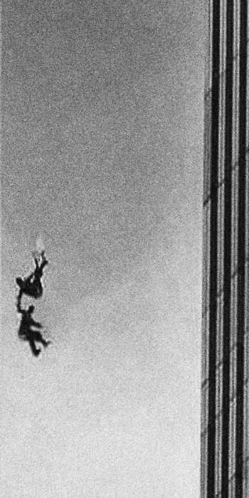

Mia Michaels (Choreographer) inspired piece.

Mia Michael’s piece
- Based on the loss of her father.
- She has the characteristics of a young girl in the dance – can she remember her father as an adult, or will she always think of him within the boundaries of her child-like frame of mind?
- She presents loss – (recurring theme from previous rehearsals)
- It displays the reunion of father and daughter in Heaven.
- Flowers – symbol of both loss and new beginnings.
- Exploration of equal weight distribution.
- Strong link to photographs and memory.
- How the body can present emotion.

Linked with 9/11 attacks in our work.
Subtlety of dance is contrasted with abrupt actions from the rest of the company.

Area’s to develop:
- If used in final piece, explore options of getting into the beginning of the movement. We don’t want the ‘dance’ to just begin.
- Consider lighting – will the company be in control of lighting the dancing couple?

