What have we done so far, and where are we going?

- In-depth discussion with full team about what we have done so far. What has worked, what hasn’t worked, where are there room for improvements rehearsal-wise? and any new ideas that have sparked from exploration.
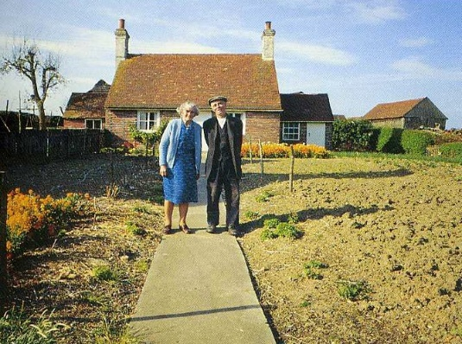
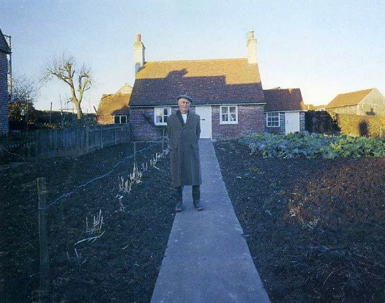
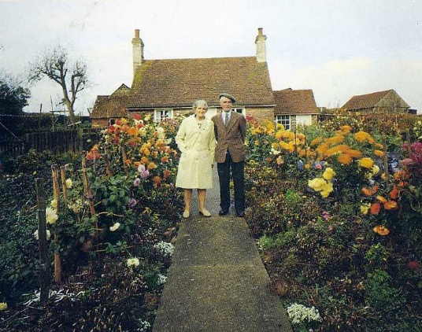
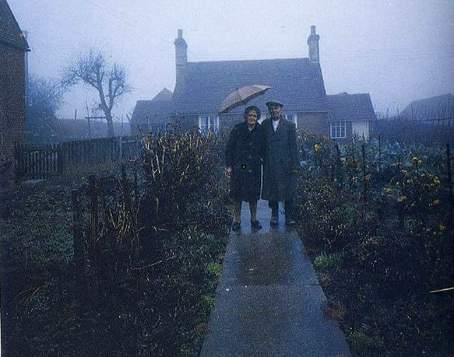
Theme of Loss & New Beginnings.
- Throughout the process, these two themes have been surfacing from the material time and time again.
- Discussed idea of through-line being the recreation of the viral story of an elderly couple who took a photo together every season.
- How do you photograph loss?
-Creative
- Using different costumes on the stage.
-Same two people throughout.
- Camera noise and flash of light – photograph being taken
- Projection – Actual photo outside of theatre, change in weather. Actual photo, holding an umbrella. Stage photo – same position, no props. (Neil Patrick Harris Oscars opening inspired)
-Old to new – at the end, one of them has died.

Retakes and Misinterpretation.
- What goes on outside of the frame?
- As a society, retaking photos is readily available. What happens if we think about how famous photos turned out differently?
- Points of Disscussion: Recreating NY Times Square photo.
- A selfie for every occasion. “Which filter best suits my brother’s funeral?”
Creative
-Build up NYC to be a really romantic moment. Then bam, it’s not. The girl could drop. The man could scream. Bird poo on her face. He could be mugging her. She could be mugging him.
-Frame comes down as a fly – framing certain things on stage, using lighting to only hit that area.
-Set Design: different elements of all of the photographs being used.
-Selfie Song – create an original piece of Acoustic music to be performed.
-Change the style/tempo of music depending on the selfie pose.
-Physically carry in filters.
-Use of Emoji’s?
-“Selfie in Nandos” – can’t tell. Its just your face.

General notes
- Loved use of balloon and actually being directed on stage. Pre-recorded voice directing them. Maybe not literal direction, but environmental descriptions that make sense to actors.
- Develop pushing and shoving of Steph.
- Are you falling? Or are you flying?
- Amy’s Poem. “Mother…”
- Photographing the future – CT scans.
- Photographs have no voice. Adding narration?
- Images are always on stage – through posters, Easels, Tv Monitors. They have attention drawn to them at certain points.
To Do List – scenes to develop over next few weeks.
- Falling Man
- Men on ledge/Bus scene
- Pinball
- Photo’s have no voice – changing narrative. Reacting to words. Changing image intentions.
- Balloon/Bubble – Direction exploration.
- Acoustic Music Sessions.
- Man & Woman photograph – through-line story.
- Selfie section. Different types of poses.

