Lindt – Merry Christmas.
- Making a physical theatre piece based on the two figures in the window of the Sydney Seige.
- Music Used: Landon Pigg – Falling in Love in a Coffee Shop.
- Portrayal of a homosexual relationship – tying in with the developing idea of Loss, New Beginnings and Relationships.
- Play with the sense of danger and risk – explore through the movement. Moments where actors need to stand on a chair which is placed down at last minute.
- Props: News Report signs. Plastic see-through screen.
- Recreating the news report image through the live feed section by section.
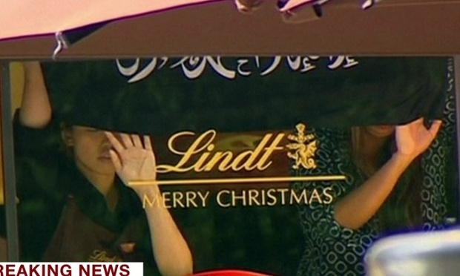
- Props used within Rehearsal:

