A Walk in the Park?

- Rehearsal based on George Seurat’s, A Sunday Afternoon on the Island of La Grande Jatte – 1884.
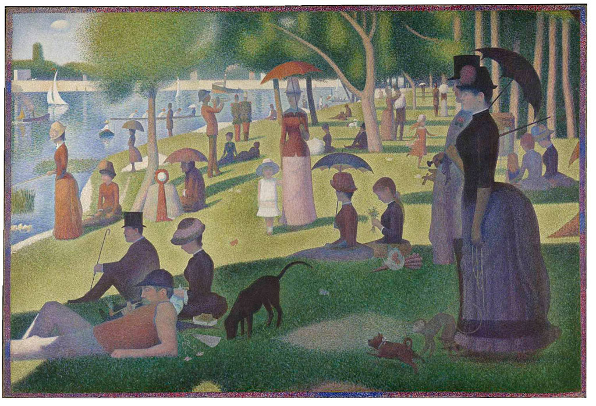

Exercise 1 –
- The Cast must choose a character from the image and copy their position as best they can.
- We will then work on perfecting these positions by critiquing each others individual position.

Exercise 2 –
- We will then form relationships between the characters and work on the way that they move.
Exercise 3 –
- Setting the movement to specific timings, the cast will then work together to depict the backstory to the painting.

Music Used: Ukulele Instrumental Mixed with A Rush of Blood to the Head, by Coldplay.

