

**Lighting Rig Diagram**

Completed By: Morgan Wills, Lighting Designer

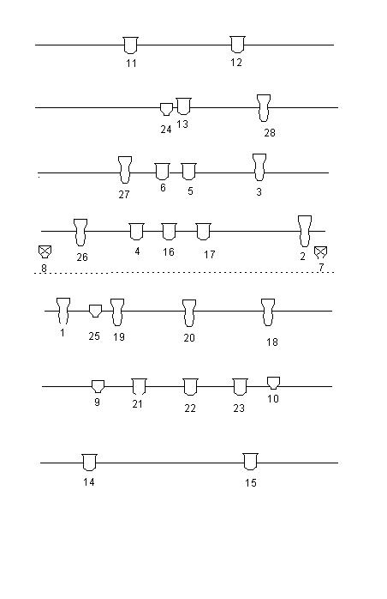

Profile x9

LED x4

Par-Can x2

Fresnel x13